Algorithm for file updates in Python

Project description
I created an algorithm that uses Python code to check whether any of the employees with access to an updated file should be removed. The allow list and remove lists both contain IP addresses which give information for the employees that must be removed.

Open the file that contains the allow list
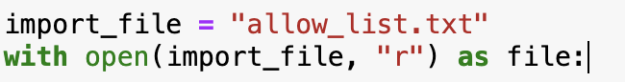
First, I set the file named allow_list.txt as the import file. Then I opened it using with and open() with arguments as the import file and “r” to indicate I will only be reading the file. Then I set it as the variable named file.

Read the file contents
To read the contents of the file, I used the read() function. This reads everything in the file (allow_list.txt) and stores it as a string called ip_addresses.

Convert the string into a list
Then, I used the split() function to separate the string into a list. Since there is no argument inside the split function, I separated it by whitespace (the space between words). Hence, the list contains each word in allow_list.txt as an element in the list.

Iterate through the remove list
I used the “for” and “in” keywords in Python to iterate through the remove_list and access each element.

Remove IP addresses that are on the remove list
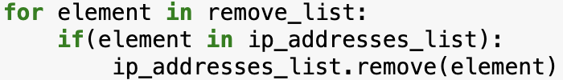
For removal of IP addresses, I added a condition (if statement) that checked if the element of the remove_list was also in the ip_addresses_list. If it was, then it was removed from the ip_address_list, using the remove() function.

Update the file with the revised list of IP addresses
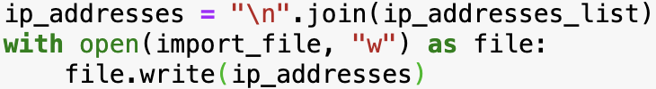
Finally, the ip_addresses_list was converted back into a string by using the join() function on the new line character (“\n”). Since each element in the list was separated by a new line, it was thus converted into the original string in the file. Then using the “with” keyword and open(), I used the “w” argument to indicate that I was writing to the import_file. I called it by the variable name file and then used the write() function to write ip_addresses to the file to update it.

Summary
I created an algorithm which incorporated Python keywords, conditional statements, and reading and writing to a file. This algorithm was used to determine if an employee was in both the ip_addresses_list and the remove_list and then removed them from the ip_addresses_list. This algorithm can be used to periodically check whether an employee has access to restricted content and adequately constrict their access.

